**Assignment 3**

**Name: Khushdeep Kaur Chilotra Student ID: 200537527**

***Application Requirements***

1. Completing the design from the wireframe. Completing making the application from the design.

1. Enhancing the views and making the app complete. Adding more functionality features like CRUD, click on the check box to complete the task to be done and pending. It also gets uploaded to the firebase Realtime.

* Firstly I have updated the google signin button. I have change the look of the login with google button.

Before After

* Then I have added the functionality of the app by, user can click on the task to mark the tasks as done.

Before After

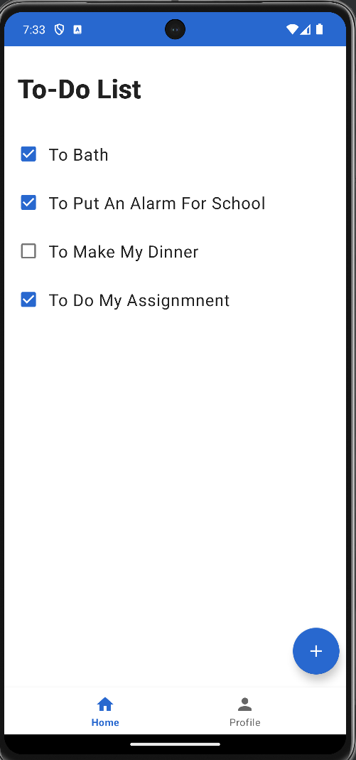

* I have also added the functionality of the application is now the users can delete the tasks as well from the app after doing it.

Before After

* I have also added the functionality that now the users can update the task as well even after adding the tasks.

Before After After

1. Secure firebase connection

1. Create Launcher Icon

1. Google play Store Listing for testers

Link : https://play.google.com/store/apps/details?id=com.project.assign2

